Pursuant to Chapter 38 of the Listing Rules, the Securities and Futures Commission regulates Hong Kong Exchanges and Clearing Limited in relation to the listing of its shares on The Stock Exchange of Hong Kong Limited. The Securities and Futures Commission takes no responsibility for the contents of this announcement, makes no representation as to its accuracy or completeness and expressly disclaims any liability whatsoever for any loss howsoever arising from or in reliance upon the whole or any part of the contents of this announcement.

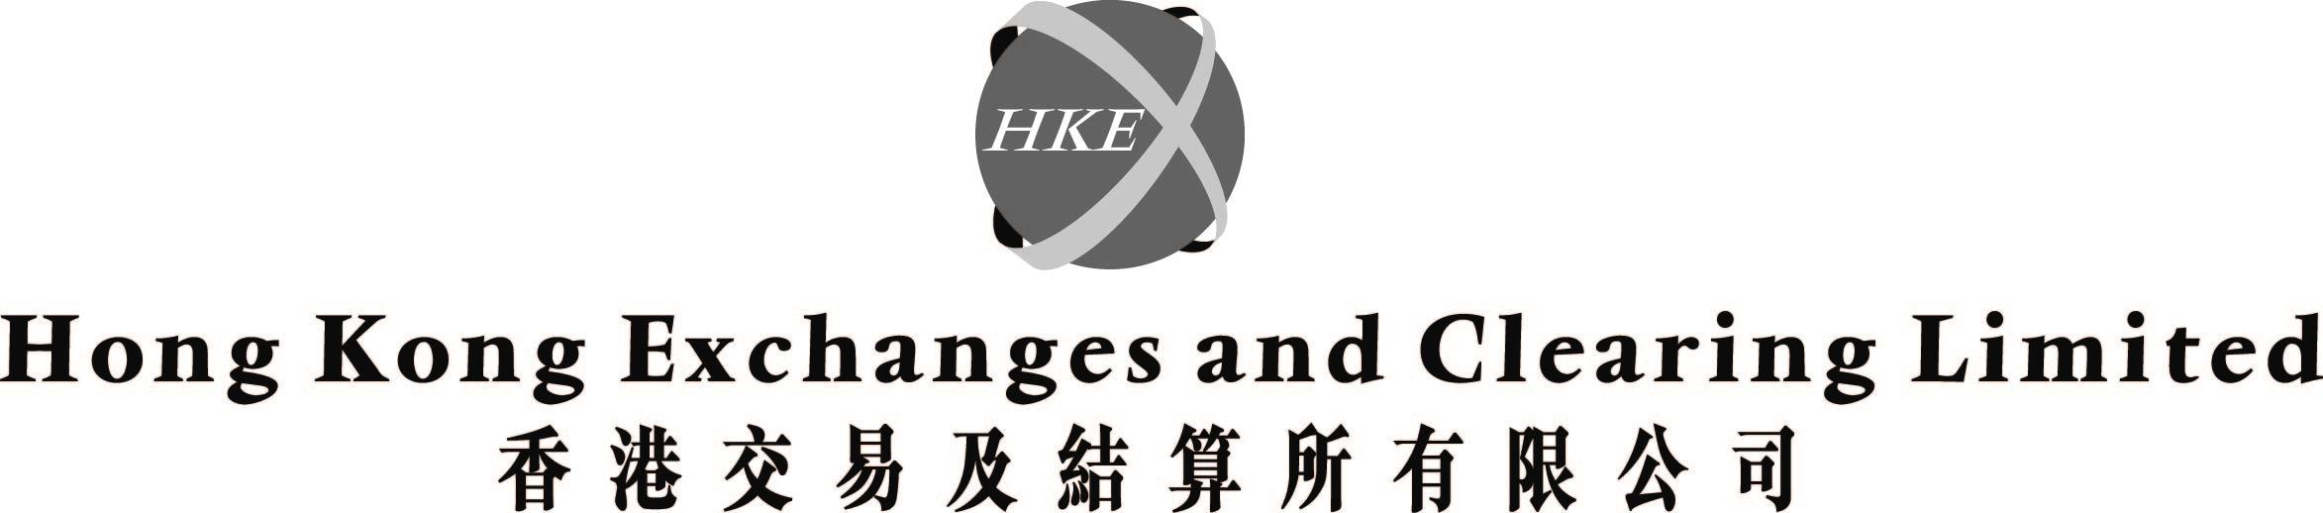
(incorporated in Hong Kong with limited liability under the Companies Ordinance)

Withdrawal of intention to propose a resolution for the appointment of Mr Parker, David Charles as a director at the 2003 Annual General Meeting of Hong Kong Exchanges and Clearing Limited ("HKEx")

INTRODUCTION

On 3 April 2003, a shareholder of HKEx ("the Relevant Shareholder") had notified the Company Secretary of its intention to propose a resolution for the appointment of Mr Parker, David Charles as a director at the 2003 annual general meeting of HKEx to be held on Tuesday, 15 April 2003 ("AGM"). Details of the proposed appointment of Mr Parker have been included in the supplemental circular of HKEx dated 8 April 2003. A Second Proxy Form was enclosed with the supplemental circular. As Shareholders are aware, the resolution in respect of the election of Mr Parker will only be put to the meeting for voting at the AGM if the Relevant Shareholder does in fact propose such a resolution at the AGM.

WITHDRAWAL OF NOMINATION

The Relevant Shareholder has, on 9 April 2003, notified the Company Secretary of the withdrawal of its notice of intention to propose a resolution for the appointment of Mr Parker as a director of HKEx at the AGM. On the same date, Mr Parker also notified the Company Secretary of the withdrawal of his consent to be appointed as a director of HKEx. Accordingly, Shareholders should note that no resolution for the appointment of Mr Parker as a director of HKEx is expected to be put to the AGM for voting.
SECOND PROXY FORM

No further proxy form will be issued by HKEx. Shareholders should use the Second Proxy Form for appointing proxies, and giving voting instructions to their proxies. As the Relevant Shareholder will not propose a resolution to appoint Mr Parker as a director at the AGM, Shareholders may ignore resolution no. 3(XI) shown on the Second Proxy Form in relation to the resolution to appoint Mr Parker. For the avoidance of doubt, a correctly completed Second Proxy Form will not be invalidated even though an instruction to vote has been given in respect of resolution no. 3(XI). Shareholders who have any query about the validity of the proxy form deposited may contact HKEx's registrar at 2862-8666.

By order of the Board
Hong Kong Exchanges and Clearing Limited
Joseph Mau
Company Secretary

Hong Kong, 9 April 2003

Please also refer to the published version of this announcement in the South China Morning Post dated 10 April 2003.

