Pursuant to Chapter 38 of the Listing Rules, the Securities and Futures Commission regulates Hong Kong Exchanges and Clearing Limited in relation to the listing of its shares on The Stock Exchange of Hong Kong Limited. The Securities and Futures Commission takes no responsibility for the contents of this announcement, makes no representation as to its accuracy or completeness and expressly disclaims any liability whatsoever for any loss howsoever arising from or in reliance upon the whole or any part of the contents of this announcement.

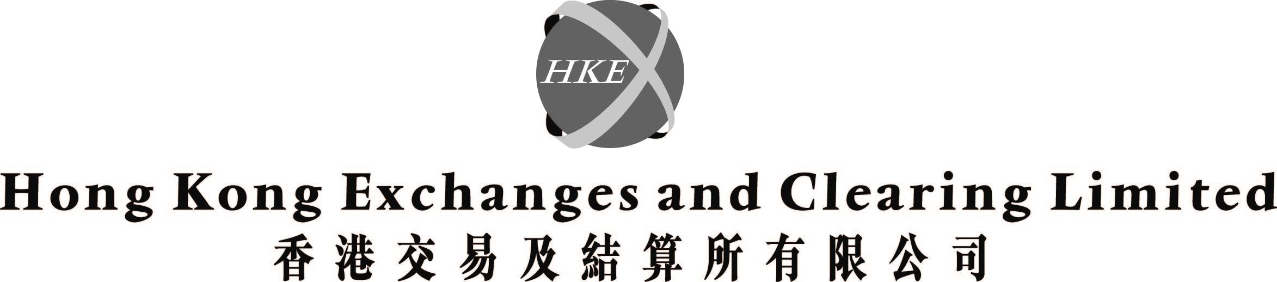
(incorporated in Hong Kong with limited liability under the Companies Ordinance)

Further information in respect of the Appointment of Directors at the 2003 Annual General Meeting of Hong Kong Exchanges and Clearing Limited ("HKEx")

INTRODUCTION

HKEx has despatched to its Shareholders a circular dated 18 March 2003 ("Circular") in respect of certain matters to be dealt with at the 2003 annual general meeting of HKEx ("AGM"), including the appointment of Directors.

The AGM will be held at the Trading Hall of The Stock Exchange of Hong Kong Limited at 1st Floor, One and Two Exchange Square, Central, Hong Kong on Tuesday, 15 April 2003 at 4:30 p.m.

ADDITIONAL CANDIDATES

Article 90(2) of the Articles of Association of HKEx provides that no person (other than a Director retiring in accordance with the Articles of Association) shall be appointed a Director at the AGM unless (a) he is recommended by the Directors or (b) not less than seven nor more than 28 clear days before the date appointed for the meeting, a Shareholder (who is not the person to be proposed) has given to the Company Secretary notice of his intention to propose a resolution for the appointment of that person and a notice executed by that person of his willingness to be appointed.

Subsequent to the despatch of the Circular, the Company Secretary has received from Shareholders notifications of their intention to propose resolutions for the appointment of the following persons as directors at the AGM pursuant to Article 90(2)(b) of the Articles of Association:

1. Mr Chan, Henry

2. Mr Lam Kin Hing, Kenneth

3. Mr Parker, David Charles

The deadline for Shareholders to give notice of any intention to propose a resolution pursuant to Article 90(2)(b) expired on 7 April 2003. Including Mr Chan, Mr Lam and Mr Parker, there are a total of 11 candidates standing for election as Directors at the AGM. Shareholders may, if thought fit, appoint up to six candidates as Directors at the AGM. In order to select which six candidates will be elected Directors, the resolutions to be proposed at the AGM will contain a method of determining support for a candidate, all as set out in the Circular.

A supplemental circular ("Supplemental Circular") containing the biographies of the additional proposed candidates supplied by the relevant Shareholders to HKEx together with a new proxy form ("Second Proxy Form") are being sent to all Shareholders on 8 April 2003.

PROXY FORM

As a result of the additional proposed resolutions received from Shareholders subsequent to the despatch of the Circular, the proxy form sent together with the Circular and Annual Report 2002 of HKEx ("First Proxy Form") does not contain the proposed resolutions for the appointment of the additional candidates set out in the Supplemental Circular. In this connection, the Second Proxy Form has been prepared and is enclosed with the Supplemental Circular.

Shareholders are requested to complete the Second Proxy Form in accordance with the instructions printed thereon and return it to the office of HKEx's registrar, Hong Kong Registrars Limited, at Rooms 1901-5, 19/F, Hopewell Centre, 183 Queen's Road East, Hong Kong as soon as possible and in any event not less than 48 hours before the time appointed for holding the AGM, i.e., 4:30 p.m. on Sunday, 13 April 2003 ("Closing Time"). Special arrangements about the Second Proxy Form are also set out in the Supplemental Circular. Shareholders who have appointed or intend to appoint proxies to attend the AGM are requested to pay particular attention to the special arrangements set out therein. In particular:

(a) A Shareholder who has not yet lodged the First Proxy Form with HKEx's registrar is requested to lodge the Second Proxy Form if he wishes to appoint proxies to attend the AGM on his behalf. In this case, the First Proxy Form should not be lodged with the HKEx's registrar.

(b) A Shareholder who has already lodged the First Proxy Form with HKEx's registrar should note that:

(i) If no Second Proxy Form is lodged with HKEx's registrar, the First Proxy Form, if correctly completed, will be treated as a valid proxy form lodged by him. The proxy so appointed by the Shareholder will be entitled to vote at his discretion or abstain on any resolution properly put to the AGM other than those referred to in the notice convening the AGM and the First Proxy Form, including a resolution for the appointment of an additional candidate set out in the Supplemental Circular as Director.

(ii) If the Second Proxy Form is lodged with HKEx's registrar before the Closing Time, the Second Proxy Form, if correctly completed, will be treated as a valid proxy form lodged by the Shareholder and will revoke and supersede the First Proxy Form previously lodged by him.

(iii) If the Second Proxy Form is lodged with HKEx's registrar after the Closing Time, the Second Proxy Form will be invalid. However, it will revoke the First Proxy Form previously lodged by the Shareholder, and any vote that may be cast by the purported proxy (whether appointed under the First Proxy Form or the Second Proxy Form) will not be counted in any poll which may be taken on a proposed resolution. Accordingly, Shareholders are advised not to lodge the Second Proxy Form after the Closing Time. If such Shareholders wish to vote at the AGM, they will have to attend in person and vote at the AGM themselves.

The Circular, the Supplemental Circular and the Second Proxy Form can be downloaded from HKEx's website at
http://www.hkex.com.hk.

Shareholders are advised to read the Supplemental Circular together with the Circular for complete information of all candidates and the voting arrangements.

By order of the Board
Hong Kong Exchanges and Clearing Limited
Joseph Mau
Company Secretary

Hong Kong, 8 April 2003

Please also refer to the published version of this announcement in the South China Morning Post dated 8 April 2003.

