Pursuant to Chapter 38 of the Listing Rules, the Securities and Futures Commission regulates Hong Kong Exchanges and Clearing Limited in relation to the listing of its shares on The Stock Exchange of Hong Kong Limited. The Securities and Futures Commission takes no responsibility for the contents of this announcement, makes no representation as to its accuracy or completeness and expressly disclaims any liability whatsoever for any loss howsoever arising from or in reliance upon the whole or any part of the contents of this announcement.

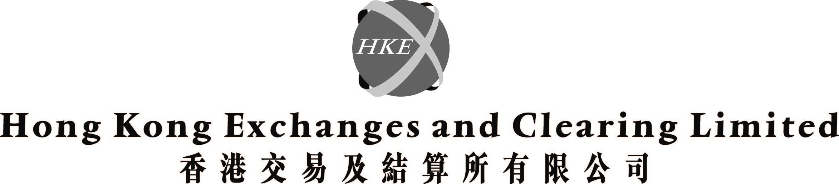
(incorporated in Hong Kong with limited liability under the Companies Ordinance)

The shareholders of Hong Kong Exchanges and Clearing Limited ("HKEx") have approved the amendments to the post listing share option scheme of HKEx adopted by shareholders on 31 May 2000 ("Share Option Scheme").

The Board of Directors of HKEx is pleased to announce that an ordinary resolution to approve the amendments to the Share Option Scheme in the manner as explained in the circular to shareholders of HKEx dated 13 March 2002 was duly passed at the annual general meeting held on 17 April 2002.

By Order of the Board
Hong Kong Exchanges and Clearing Limited
Joseph Mau
Company Secretary

Hong Kong, 17 April 2002

Please also refer to the published version of this announcement in the South China Morning Post dated 18/4/2002

