The Securities and Futures Commission takes no responsibility for the contents of this announcement, makes no representation as to its accuracy or completeness and expressly disclaims any liability whatsoever for any loss howsoever arising from or in reliance upon the whole or any part of the contents of this announcement.

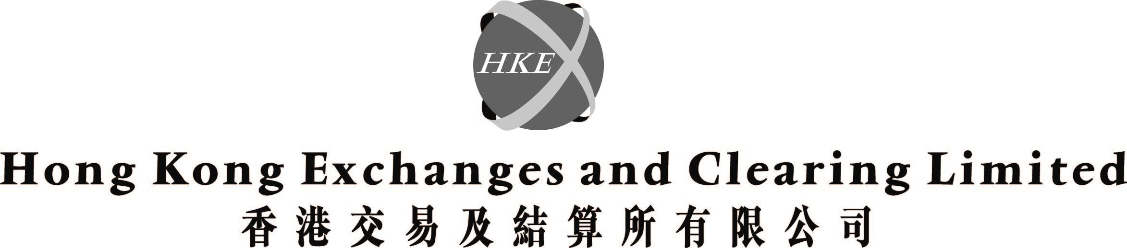
(incorporated in Hong Kong with limited liability under the Companies Ordinance)

Hong Kong Exchanges and Clearing Limited ("HKEx") is, in accordance with note (8) of Rule 2.07B(2) of the Listing Rules, making adequate arrangements to ascertain the wishes of members as to which language version of Corporate Communications of HKEx they wish to receive in the future.

INTRODUCTION

On 15 February 2002, amendments to the Listing Rules have been effected to allow listed issuers to send Corporate Communications to members and holders of their listed securities either in the English language only, or the Chinese language only, or both the English and Chinese languages, in each case (in accordance with the stated wish of each member and securities holder), subject to certain adequate arrangements being made.

PROPOSED ARRANGEMENTS

In accordance with note (8) of Rule 2.07B(2), the following arrangements have been or will be made by HKEx:

1. HKEx is sending a letter on 28 February 2002 together with a pre-paid reply slip (the "First Letter"), prepared in English and Chinese, to its members to enable them to select whether to receive either an English or Chinese or both versions of all Corporate Communications. The First Letter will explain that if no reply is received from such members by 14 March 2002, the following arrangements will apply, where applicable:

‧ the Chinese language version of Corporate Communications will be sent to all Hong Kong members who are natural persons with a Chinese name; and

‧ the English language version of Corporate Communications will be sent to all overseas and all Hong Kong members other than natural persons with a Chinese name.

Whether a member of HKEx is a Hong Kong or an overseas person will be determined by his or its address as appearing in the register of members.

Members have the right at any time by reasonable notice in writing to HKEx to change the choice of language of Corporate Communications.

2. HKEx will send the selected language version of Corporate Communications to those members who have made a selection unless and until they notify HKEx in writing that they wish to receive Corporate Communications in the other (or both) language(s).

3. When each Corporate Communication is sent out according to the arrangements as set out in paragraph 1 above, a letter together with a pre-paid request slip (the "Second Letter"), prepared in English and Chinese, will be attached to or printed at some prominent place in the sent out versions of the Corporate Communication stating that the Corporate Communication prepared in the other language will be available upon request.

4. Corporate Communications in both English and Chinese versions and in accessible format will be available on HKEx's website (http://www.hkex.com.hk) and a copy in electronic format of each Corporate Communication in both languages will be filed with the SFC and the SEHK on the same day as such Corporate Communication is sent to members.

5. HKEx is providing a dial-up hotline (Tel: 2815-8820) to enable members to make enquiry of HKEx's proposed arrangements.

6. The First Letter and the Second Letter will mention that Corporate Communications will be available in both languages on HKEx's website and that the dial-up hotline has been provided as mentioned in paragraphs 4 and 5 above respectively.

DEFINITIONS

In this announcement, the following expressions have the meanings set out below unless the context requires otherwise:

"Corporate Communication" | any document issued or to be issued by HKEx for the information or action of holders of any of its securities, including but not limited to:-
 | (a) | the directors' report and annual accounts together with a copy of the auditors' report;
 | (b) | the interim report;
 | (c) | a notice of meeting; and
 | (d) | a circular
"Listing Rules" | the Rules Governing the Listing of Securities on The Stock Exchange of Hong Kong Limited
"SEHK" | The Stock Exchange of Hong Kong Limited
"SFC" | the Securities and Futures Commission

By order of the Board
Hong Kong Exchanges and Clearing Limited
Joseph Mau
Company Secretary

Hong Kong, 28 February 2002

Please also refer to the published version of this announcement in the South China Morning Post dated 1/3/2002

